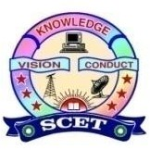

Event no: V
AICTE IDEA Lab Activity Report – Event V
Title of the Activity
Innovation Day Celebration
Type of Activity
Innovation Awareness & Student Engagement Program under AICTE IDEA Lab
Organizing Unit
AICTE IDEA Lab and Entrepreneurship Development Cell (EDC)
Date & Venue
- Date: 15-10-2025
- Venue: Swarnandhra College of Engineering & Technology (Seminar Hall)
Objective of the Activity
The Innovation Day celebration was organized with the objective to:
- Promote a culture of innovation, creativity, and problem-solving among students
- Encourage hands-on learning and ideation using AICTE IDEA Lab facilities
- Create awareness about national innovation initiatives and startup ecosystem
- Motivate students to develop innovative ideas, prototypes, and startup concepts
Participants
- Students from various departments
- Faculty members and IDEA Lab coordinators
- Number of Participants: 60
Description of the Activity
As part of the AICTE IDEA Lab initiative, Innovation Day was celebrated on 15th October 2025 at Swarnandhra College of Engineering & Technology. The event included talks on innovation and entrepreneurship, student idea presentations, poster displays, and interaction sessions. Students showcased innovative ideas and early-stage prototypes developed through design thinking and hands-on experimentation encouraged by the AICTE IDEA Lab. Faculty members guided students on refining ideas into feasible projects and startups.
Role of AICTE IDEA Lab
- Provided an ecosystem for ideation, innovation, and experimentation
- Encouraged interdisciplinary participation
- Supported prototype-oriented and experiential learning
- Acted as a platform for nurturing future innovators and entrepreneurs
Outcomes of the Activity
- Increased awareness of innovation and entrepreneurship
- Identification of promising ideas for further development in the IDEA Lab
- Improved student confidence and creative thinking skills
- Enhanced utilization of AICTE IDEA Lab infrastructure
- Motivation for students to pursue startups, incubation, and research-based innovation
Impact
The Innovation Day celebration strengthened the innovation culture on campus and reinforced the role of the AICTE IDEA Lab as a catalyst for skill development, creativity, and startup orientation among students.
Conclusion
The Innovation Day event successfully fulfilled the objectives of the AICTE IDEA Lab Scheme by fostering innovation-driven learning and entrepreneurial thinking. Such initiatives contribute significantly to building a sustainable innovation and startup ecosystem at Swarnandhra College of Engineering & Technology.

Gallery
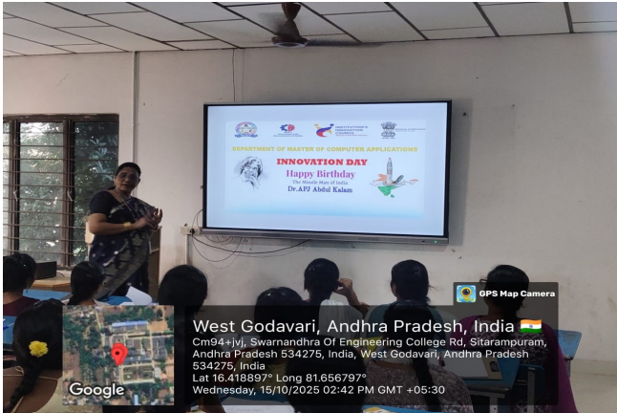 | 